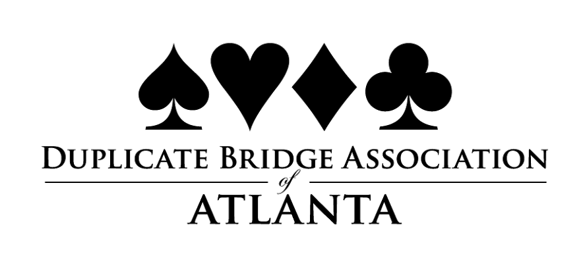
Atlanta’s annual Labor Day Regional Tournament at the Crowne Plaza at Ravina (across from Perimeter Mall) is happening August 27 – September 2. For the full schedule and flyer, click HERE

Each Fall the DBAA selects a Sportsperson of the Year (SPOTY). This person is honored for their admirable ethical behavior and strong sense of fair play over an extended period of time and for their outstandingly pleasant and gracious comportment at the table. It is available to any member of the DBAA regardless of their level of achievement in bridge. Each year the SPOTY will be awarded free plays for all of the DBAA Sectional tournaments in the following calendar year and a certificate so stating.
Nominations should be received no later than October 1st of each year. Jan Noll chairs this committee and she will be sending nomination instructions to all….soon. Please note that no member of the DBAA Board of Directors or the Committee is eligible for this award as long as they may serve and no member may be selected more than once.

The annual Mentor Program (May is for Mentoring) was wildly successful this year with participation throughout the area. The final numbers are not available yet as all the reimbursements haven’t been made, but the reports from the clubs have been extremely encouraging. The month culminated with the Friendship Championship Game which was a 2 session event held at ADBC on June 9th. Many thanks to Dan Papineau for the use of his club and to Nancy Watkins for directing. Congratulations to the winners: Maggie Miller and David McRae. For a full report on the event, please click HERE

What is the DBAA ?
The DBAA or Duplicate Bridge Association of Atlanta is Unit 253 of the ACBL. The Association is granted some rights and responsibilities from the ACBL but the primary focus is to promote bridge in the metropolitan Atlanta area. In that role, the DBAA organizes, promotes, develops, and manages various bridge activities to benefit the area players and to encourage new players to join our ranks.

The organization is funded by tournament receipts and by a small percentage of our members’ dues. We are always seeking volunteers to help us with this programming. Please let our President know if you are willing to help. Email: President@dbaa.us. To visit the website, click HERE

HAVE YOU JOINED PIANOLA?
The DBAA uses PIANOLA as its database to store member’s names, addresses, phone and email information. As a member, you may have access, create a profile and choose what information you want other members to see.
In order to access the information, go to www.dbaa.us and click on “Log in to Pianola” in the upper right hand corner of the page. If this is your first time to enter the site, you will need to create an ACCESS CODE and a PASSWORD. Once you are inside PIANOLA, you can create or update your profile information and indicate what information you want other members to see. You can also find partners on this site, so log in and look around. (Forgot your access code or password? Contact Sue Williams for assistance. On the front page of the DBAA website www.dbaa.us there is great information about upcoming tournaments, results from previous tournaments, and spotlights on people and events taking place in the Chapter. Questions or having a problem logging in? Contact Sue Williams at 678-642-6189 or szw2584@gmail.com

